OB Sim Day Teaching Points

Shoulder dystocia

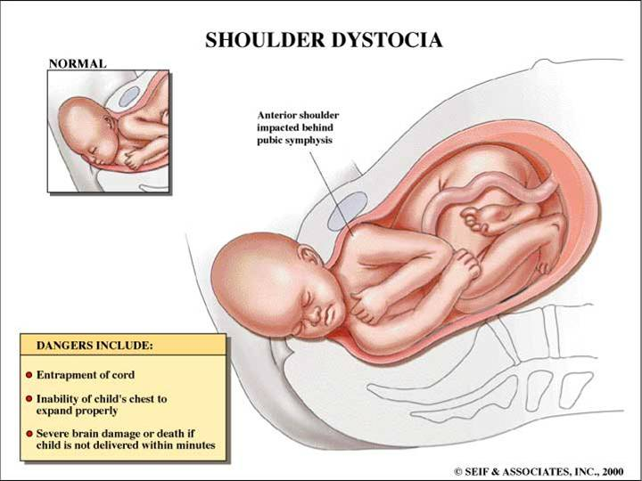

- Failure of the fetal shoulders to clear after the head is delivered
  - Occurs in 0.6 to 2% of all vaginal deliveries
  - Diagnosed in the intrapartum period; may not be predictable based on prenatal data
- Rare obstetric emergency, unpredictable
- Serious potential harm for morbidity for mother and baby, esp brachial plexus injury, may be exacerbated by inappropriate management
- Maternal and fetal factors leading to this condition:
  - Maternal factors: DM, obesity, multiparity, precipitous or protracted labor
  - Fetal factors: Macrosomia, post-dates
- Complications include
  - Fetal: Brachial plexus injuries, humeral/clavicular fractures, aspiration, hypoxic brain injury (from cord compression or compression of the lungs)
  - Maternal: Post-partum hemorrhage, vaginal, perineal or sphincter tears, incontinence

- Diagnosis: Clinical – when the shoulder cannot be delivered and delivery arrests
  - Fetus may “retract” into the perineum (“turtle sign”).

- Management:
  - First things first – call for help! OB, NICU/PICU team, anesthesia
  - Initial steps – increase the AP diameter of the passage
    - Cut an episiotomy and drain the bladder with a Foley
  - 1st maneuver: McRoberts’ maneuver
    - Flexion/hyperflexion of the maternal thighs in the knee to chest position.
    - Successful in up to 40% of cases when used alone
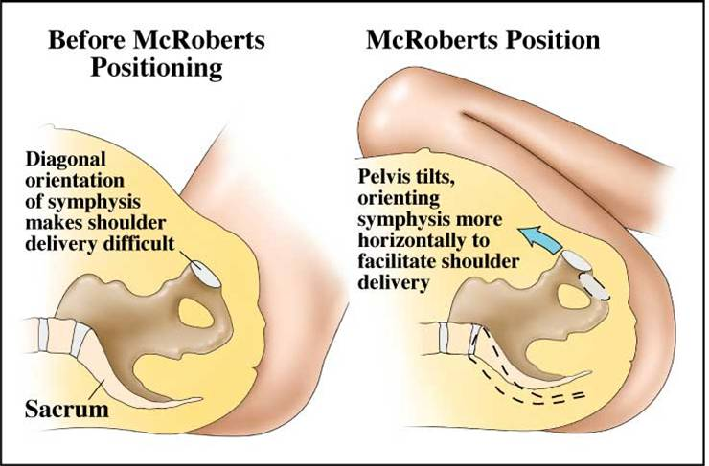

  - Next step: Suprapubic pressure to push the anterior shoulder under the pubis
    - Not fundal pressure
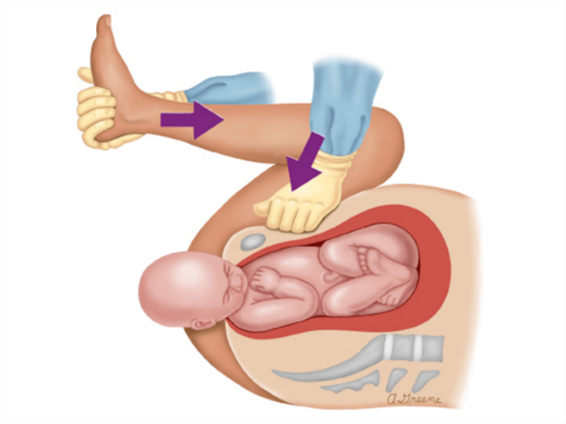

  - If that fails:
    - Rubin’s maneuver: push the most accessible shoulder to the fetal chest (transabdominal, via the introitus or through the episiotomy)

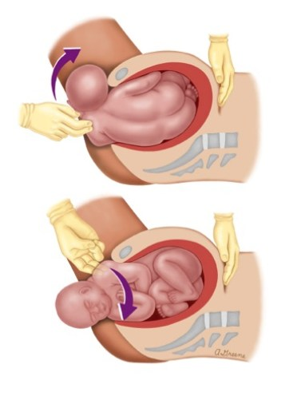

    - Wood’s corkscrew maneuver: rotate the fetus 180 degrees to release the impacted shoulder
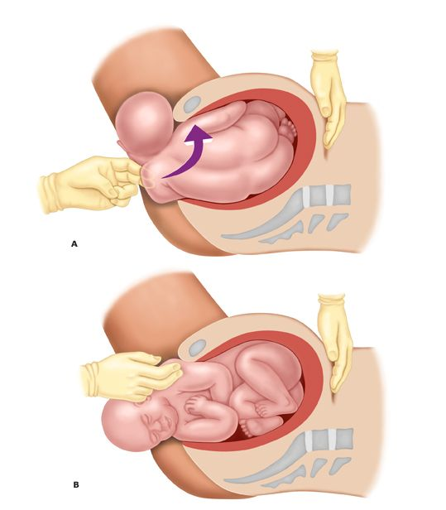
    - Pull on the posterior arm
  - Next??
    - Break the clavicle, symphisotomy, Zavanelli maneuver (push the baby back in), Gaskin all-fours maneuver

Postpartum hemorrhage
- Occurs in 1-5% of births in US
- EBL > 1000ml
- Causes: 4Ts
  - Tone: Usually result of uterine atony, 80%
  - Trauma: Lacerations, surgical incisions, uterine rupture
  - Thrombin: Coagulopathy leading to consumption of clotting factors and hemodilution of remaining clotting factors
  - Tissue: Retained placenta
- Risk factors: retained or adherent placenta, abnl placentation, prolonged/failure to progress labor, instrumental delivery, large gestational age newborn, hypertensive disorders (pre/eclampsia, HELLP), induction of labor, fetal demise
- Maneuvers to manage
  - Bimanual uterine massage 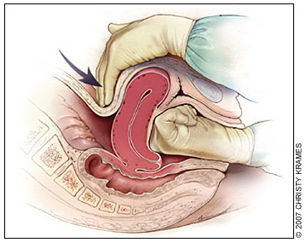
  - 1st line: Oxytocin 10-40 units diluted in IVF, (typically 40 units in 1L NS or LR) given IV adjust rate to control uterine atony, or 10 units IM if no IV access yet
  - 2nd line: Misoprostol (Cytotec, PGE1) 400 mcg SL or 1000 mcg rectal
  - 3rd line: Carboprost (Hemabate) 0.25 mg IM q15min max 8 doses (if no asthma hx)
  - 3rd line: Methylergonovine (Methergine) 0.2 mg IM repeat Q2-4 hrs (if no HTN, CAD, Raynaud’s) Trick to remember “Meth” is bad for your heart
  - Fluid resuscitate & transfuse:
    - Blood products, MTP
    - +/- Cryoprecipitate (rich w/ fibrinogen), or fibrinogen concentrate (RiaSTAP) to correct coagulopathy
  - Uterine balloon tamponade (commercially available, or improvised with #24 Foley w/ 30ml balloon, Blakemore), packing
- Consider amniotic fluid embolism, sending DIC panel

Ill-appearing neonate
- Key things to do during first 5 minutes of neonatal resuscitation
- Updated NRP guidelines 2015 http://circ.ahajournals.org/content/132/18_suppl_2/S543.long

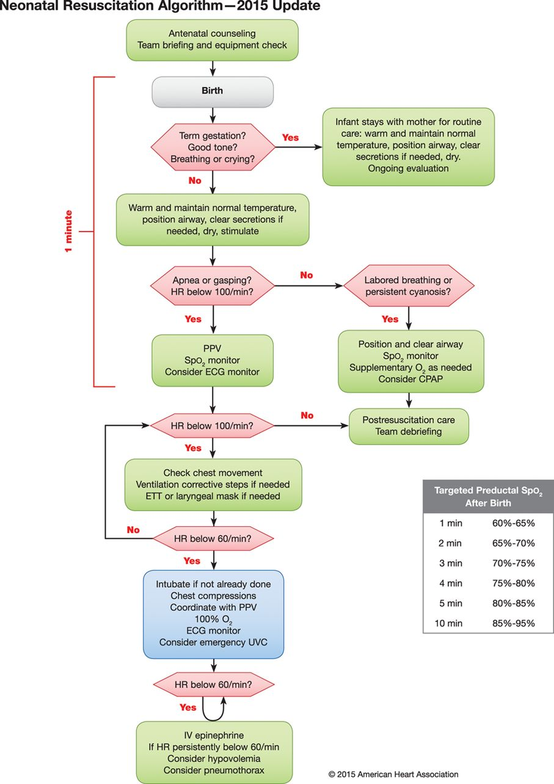
- For babies born precipitously in ED, always ask: 1) Term? 2) Good tone? 3) Breathing or crying?
  - If yes to all 3Qs, consider delaying cord clamping and hand baby to mother for skin-to-skin contact while keeping baby warm and dry.
    - Clamping of cord should be delayed 30-60 sec unless child requires immediate resuscitation
    - Associated with less IVH, NEC, better BPs and blood volume, but a/w more phototherapy requirement
  - If no to any of Qs, cut cord and begin resuscitation by:
    - Taking baby to warmer (make sure it’s on!, plastic bag from neck down) goal temp 36.5-37.5
    - Bulb syringe suction to clear secretions,
    - Dry, stimulate. Ventilate/oxygenate as needed.
    - Note time, document APGAR.
- Cutaneous temp monitor on liver – largest organ provides most consistent measurement. Hypothermia increases risk of intraventricular hemorrhage, respiratory issues, hypoglycemia, and late onset sepsis.
- Meconium aspiration no longer empirically intubated, treat similar to other babies with stimulation, suctioning, PPV as needed. Immediate intubation thought to delay resuscitation

Resuscitating a neonate: HR, RR, Pox
- HR: Detecting HR difficult, 3 lead ECG best, umbilical cord stethoscope alternate but not as accurate
  - If bradycardic HR <60, start chest compressions, thumb encircling chest wall, 3:1.
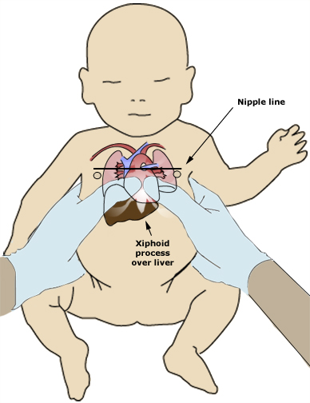
  - If not already done, intubate baby
  - Epi 1:10,000 concentration, dose 0.01 mg to 0.03 mg/kg IV, or 0.05 to 0.1 mg/kg via ETT
- RR/Pulse ox – low oxygen sat is normal in first few minutes of life. Increases by 5% every minute of life. Place monitor on R palm/wrist for pre-ductal measurement, reflects blood that is going to the brain.
  - Normal preductal (right hand) O2 Sat
  - Resuscitation with room air (FiO2 21%) initially
  - Give supplemental O2 - increase FiO2 if not achieving normal saturation or has a HR<100.
  - PPV using BVM to RR 40-60 for 30 sec, CPAP
  - If need for CPR, then intubated baby
- Intubation:
ETT = [age/4+4] | Laryngoscope blade
<28 wks 2.5 | Pre-term 0
28-34 wks 3.0 | Term 1
34-38 wks 3.5
>38 wks 3.5 to 4 | PEEP 5
Depth 3xETT size to lip

- Umbilical vein catheter: (PED Rm 4 has BOA cart w/ UVC kit)
  - http://emedicine.medscape.com/article/940865-overview
  - http://www.fprmed.com/Pages/Procedures/UmbilicalVein_Cath.html
  - Smiley face: 2 eyes = umbilical arteries, flat mouth = vein. Insert catheter into vein 2-4cm until blood flow achieved
  - DIY UVC kit – 5 Fr feeding tube, 11 blade scalpel, hemostats, forceps, 3 way stop cock, 10ml flush, umbilical tie
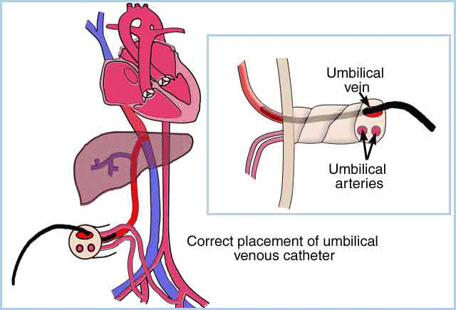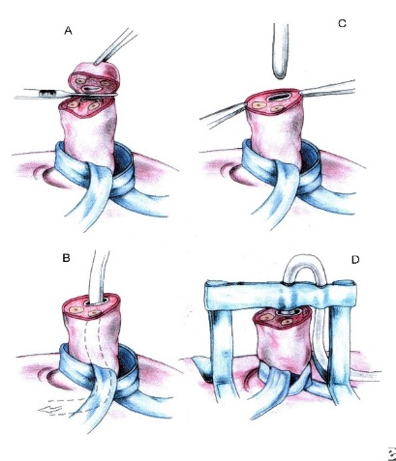
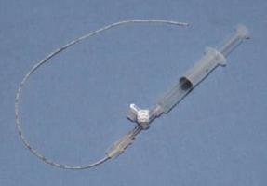
- Why does baby need resuscitation?
  - Shock? Blood or volume? Give transfusion or IVF bolus as indicated, 10ml/kg, repeat prn
  - Uterine rupture or abruption?
  - Accident with umbilical cord?
  - Hypoglycemic? 2ml/kg of D10 as initial bolus, then D10W maintenance IVF at 80ml/kg per day.

